CSE 231 Fall 2013
Computer Project #1

Assignment Overview

This assignment focuses on the design, implementation and testing of a Python program to display information about the energy released by earthquakes (see below).

It is worth 10 points (1% of course grade) and must be completed no later than 11:59 PM on Monday, September 9.

Assignment Specifications

For each of the following Richter scale measurements, your program will perform the appropriate calculations and display the equivalent amount of energy in joules and in tons of exploded TNT:

- 1.0
- 5.0
- 9.1 (Indonesia earthquake, 2004)
- 9.2 (Alaska earthquake, 1964)
- 9.5 (Chile earthquake, 1960; largest ever measured)

Your program will then prompt the user to enter a Richter scale measurement, accept a floating point value representing that measurement, perform the appropriate calculations, and display the equivalent amount of energy in joules and in tons of exploded TNT for that user-selected value.

Assignment Deliverables

The deliverable for this assignment is the following file:

proj01.py – the source code for your Python program

Be sure to use the specified file name (“proj01.py”) and to submit it for grading via the handin system before the project deadline.

Assignment Notes

The Richter scale is a way to quantify the magnitude of an earthquake using a base-10 logarithmic scale. The magnitude is defined as the logarithm of the ratio of the amplitude of waves measured by a seismograph to an arbitrarily small amplitude. An earthquake that measures 5.0 on the Richter scale has a shaking amplitude 10 times larger than one that measures 4.0, and corresponds to a 31.6 times larger release of energy. [Rephrased from Wikipedia]
The energy in joules released for a particular Richter scale measurement is given by:

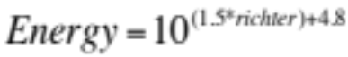

where Energy is measured in joules and richter is the Richter scale measurement (typically on a scale from 1-10 as a floating point number).

One ton of exploded TNT yields 4.184x10⁹ joules. Thus, you can relate the energy released in joules to tons of exploded TNT.

You can use the website http://www.convertalot.com/earthquake_power__calculator.html to check your work.

Commentary:

- To clarify the project specifications, we have provided sample output at the end of this document.

- The input function is used to accept a response from the user. The function takes a string (a sequence of characters between quotes) as a prompt to display to the user. It then waits until the user types a response, terminated by the user touching the Enter key. Finally, the function returns the user’s response as a string.

If the user’s response is supposed to be processed as a numeric value, the returned string must be converted into a number. When working with floating point numbers, a string is converted into a floating point number using the float function. The function accepts a string as its argument and returns the floating point number which the string represents. A typical interaction would be something like:

num_str = input( "Please enter a number: " )
num_float = float( num_str )

- The print is used to display some combination of variables, values and strings. Each item to be displayed must be separated from the other items by a comma. By default, the items will be printed together on a single line. For example:

val_float = 123.456
print( "Number ", val_float," times two: ", val_float*2 )

This command has four items to display: a string ("Number "), the value in the variable val_float (123.456), another string (" times two: ") and the result of evaluating an expression (246.912). It will print:

Number 123.456 times two: 246.912

- To indicate scientific notation in Python, use the format xey, where x and y denote numbers (float or int). For example, 4e5 is used to indicate 4*10⁵ .

- To raise a number to a power, use the ** operator. For example:

print( "10 raised to the power 1.5 is", 10**1.5 )

which results in:

10 raised to the power 1.5 is 31.622776601683793

- Python has many facilities to make output look nice, but we have not studied them yet.
Although not required, you can do simple alignment (as in the sample output) by placing strings of spaces (" ") of particular lengths in print statements. It will take some trial and error to get it to look better. Alternatively, you can use some of the features described in section 4.4 of the textbook (section 4.4.2, in particular).

Suggestions

- Solve the problem using pencil and paper first. You cannot write a program until you have figured out how to solve the problem. This first step is best done collaboratively with another student. (However, once the discussion turns to Python specifics and the subsequent writing of Python, you must work on your own.)
- Use IDLE to create a new program:
- Use the required file name (“proj01.py”).
- If you are in a CSE lab, select the H: drive as the location to store your file.
- Write a simple version of the program (perhaps one which calculates the joules for an earthquake of magnitude 1 on the Richter scale).
- Run the program and track down any errors.
- Use the handin system to turn in the first version of your program.
- Cycle through the steps to incrementally develop your program:
- Edit your program to add new capabilities.
- Run the program and fix any errors.
- Use the handin system to submit your final version.
- Be sure to log out when you leave the room, if you’re working in a public lab.

Be sure to save a copy of your completed program in your CSE file space (H: drive on the lab machines) before the project deadline. If you write your program at home and turn it in from home, you will need to copy it to your CSE file space before the deadline. In case of problems with electronic submission, an archived copy on the CSE disk is the only acceptable evidence of completion.
Sample Output

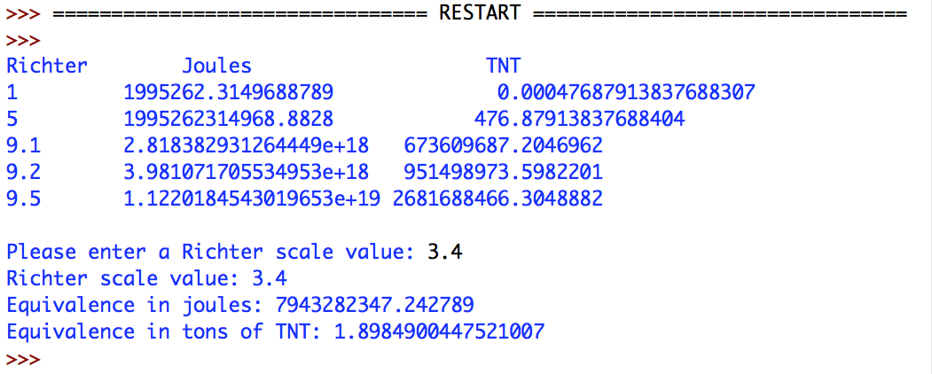

Points to Ponder

Your program is not required to process anything except a positive floating point value as the user’s response. However, it’s interesting to run your program and enter invalid responses:

- What happens if you enter a negative number at the prompt?
- What happens if you enter a letter instead of a number at the prompt?

